ການ​ນໍາ​ໃຊ້ Program planning Easy RNP.
- Create new site 2G.
- Click for Enable function.
- Click For create new site.
- Click on Map ( any place).
- Put data in as below.
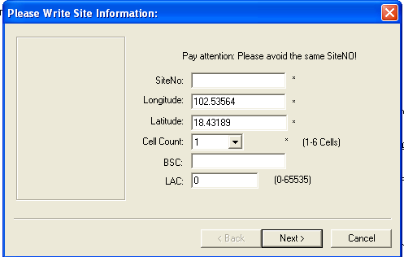

- Site No = put site name.
- Put location: Lon, Lat.
- Cell Count = put number of Cells.
- BSC = Put BSC , for BTS belong BSC.
- LAC= put LAC that BSC use.
# than Click Next.
- Put data Cell name in form as below.
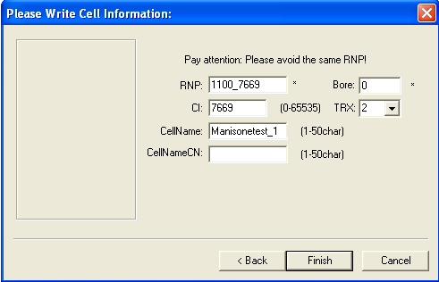
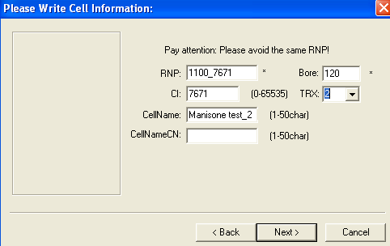
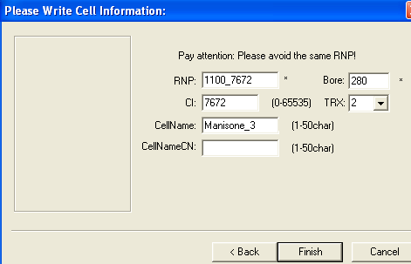
- RNP= Use LAC, CI . that we will plan , check from file excel in Export file.
- Put the cell name = Ex= Manisone test_1
- Bore = put AZ.
- TRX = Put number of TRX.
- CI = put the CI, Than click finish, site will be show on Map.
- Check all cell in property.
- Basic= put high, and Bore, tilt. other
- TRX= Put TRX number, it finished for create site as show picture below
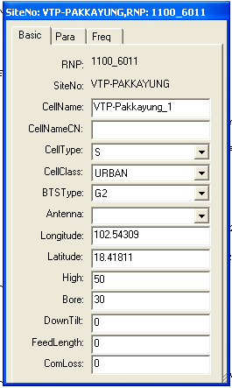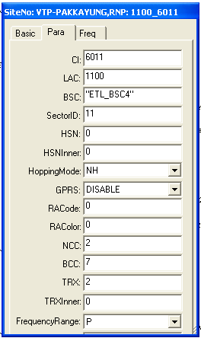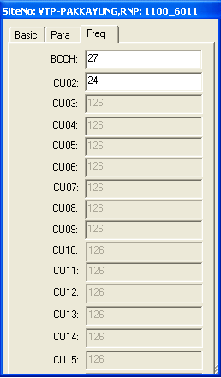
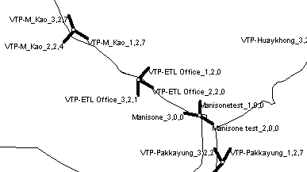
- Plan BCCH all Cell.
- Click
- Click
- Click ARFCN, Select best frequency up / donw in Key boad than click that Cell.
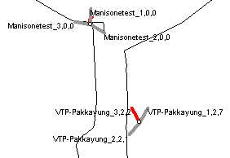
- All cell do same step one by one. After that we can check in property that cell.
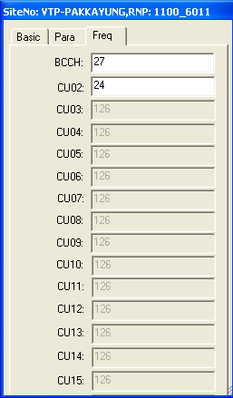

- Plan TCH.
- Click .
- Click .
- Click ARFCN, Select best frequency up / donw in Key boad than click that Cell.
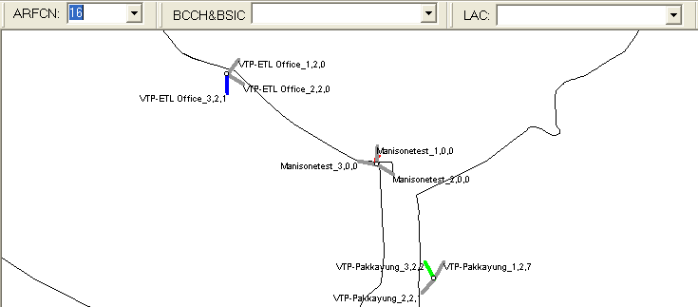
iv. Plan Neighbors Cell.
- Click .
- Click .
- Click that cell want to plan.
- Click . than select all cells need to do HO.
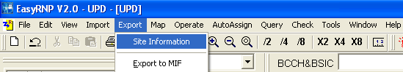

- Select = site info, Neighbors.
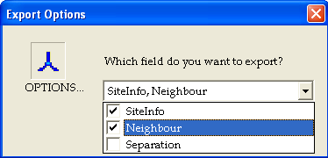
- than save it in folder.
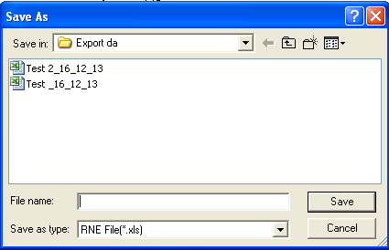
- Open file Excell.
- Cut data that site for configure. Finished.
- Use excel find that site.
- Cut for CI for NB.
- Cut Name for NB , we use Vlookup for find this.
1.
2. click
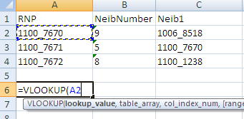

- Select sheet file cell that will show.
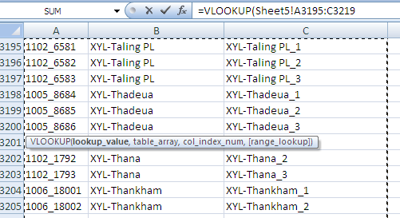
- Than click ຈຸດ.
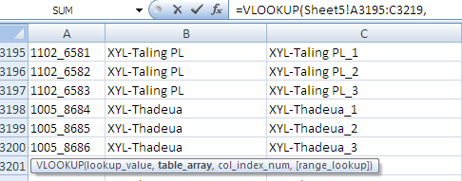
- Put 3. Than ຈຸດ​ອີກ​, ​ເລືອກ false. Enter.
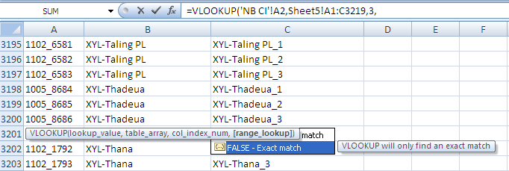
- Lock.
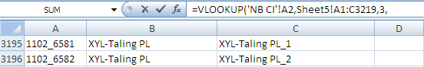
- ລາກ​ອອກ​ມາ. ​ແລ້ວ​ຕັດ​ຕໍ່​ໃໝ່, ​ໃນ​ການ Copy ຕ້ອງ​ເລືອກ​ເອົາ​ເປັນ Values only.
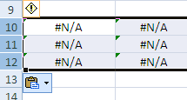

- ຈາກ​ນັ້ນ​ຈີ​ງ Cut ອອກ​ໄປ.​

- Check Frequency.
- Modify Frequency.
- Plan Extent cell.
- Plan Extend TRX.
- Plan Swap BTS.
- Move BTS.
VII. Check Neighber
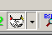
- Click ​ໃສ່ Cell ທີ່​ຕ້ອງການ​ກວດ, > click > ສັງ​ເກດ​ເບີ່​ງ​ໂຕ​ທີ່​ເປັນ NB ຈະ​ເປັນ​ສີມ່ວງ.

ການ​ Plan ສະຖານີ new site 3 G.
- ສົມມຸດມີຂໍ້ມູນ: 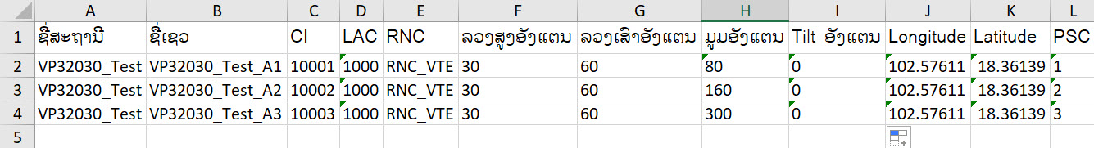
- ການສ້າງສະຖານີໃຫມ່ 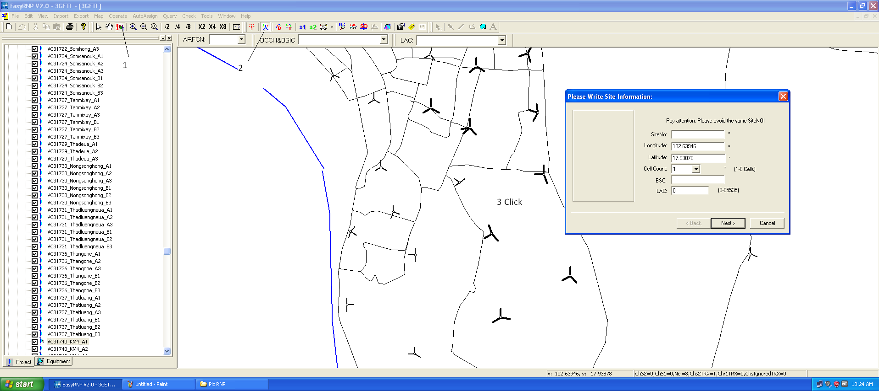 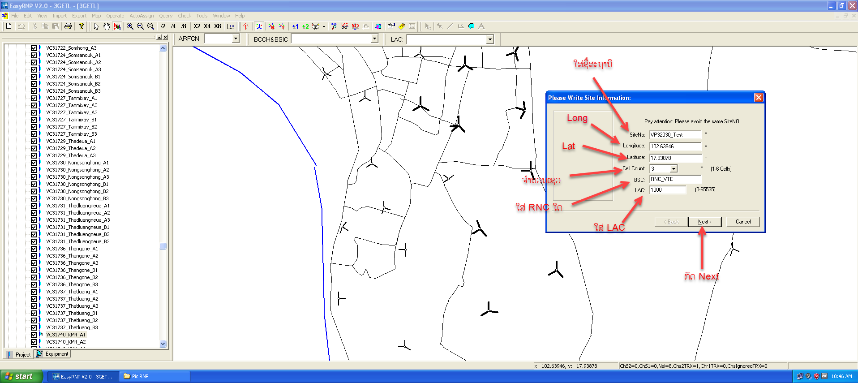 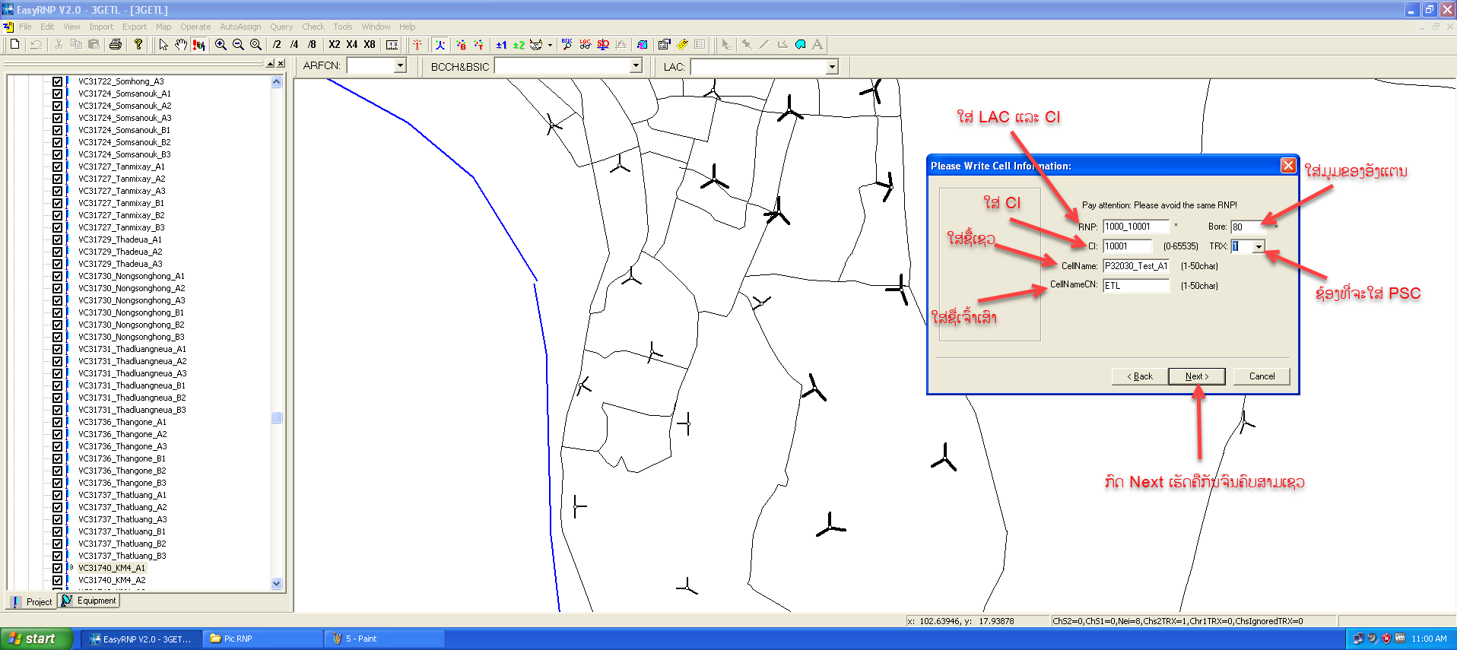
ຫລັງຈາກທີ່ໃສ່ຂໍ້ມູມຄົບທັງສາມເຊວແລ້ວໃຫ້ ກົດ finish ກໍ່ຈະເຫັນສະຖານີໃນແຜນທີ່ດັ່ງຮູບດ້ານລຸ່ມ
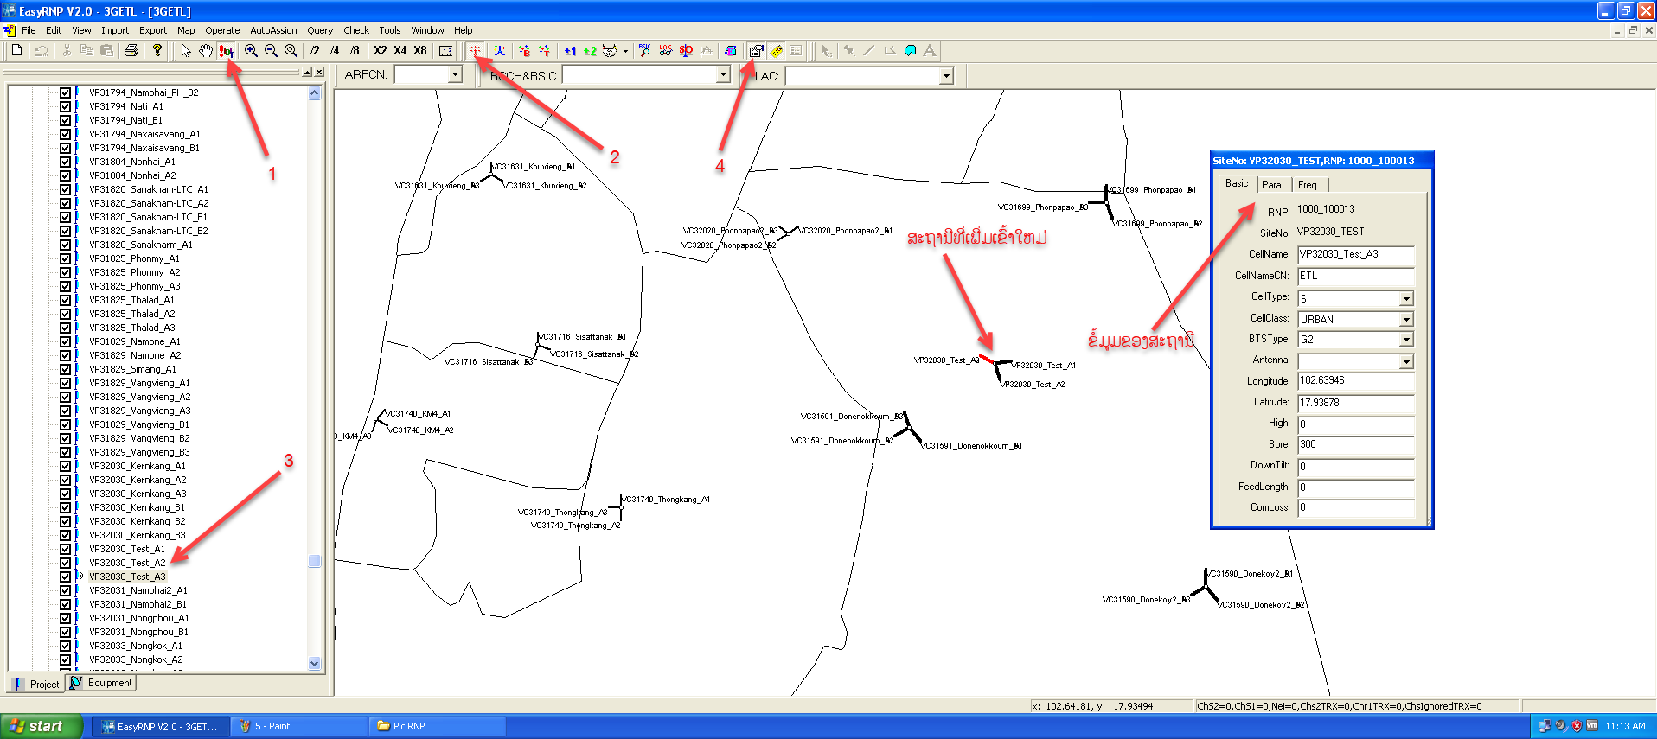
- ການຊອກເບິ່ງ PSC ເພື່ອບໍ່ໃຫ້ຕຳກັນ
ສັງເກດເບິ່ງຈາກສີ ຢູ່ RNP ຄື: ສີແດງແມ່ນຕົວດຽວກັນ,ສີຟ້າແມ່ນລື່ນ1ຕົວເລກ,ສີຂຽວແມ່ນຫລຸດ1ຕົວເລກ ດັ່ງຮູບດ້ານລຸ່ມ
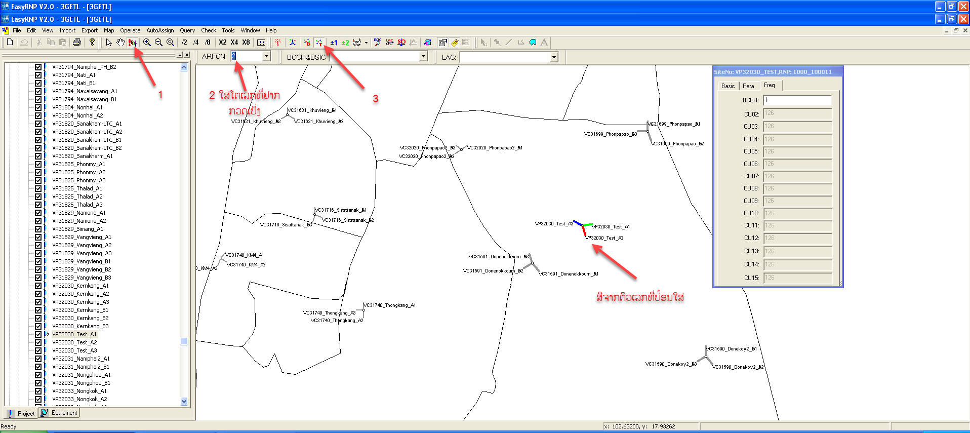
- ການເຮັດ Hand Over
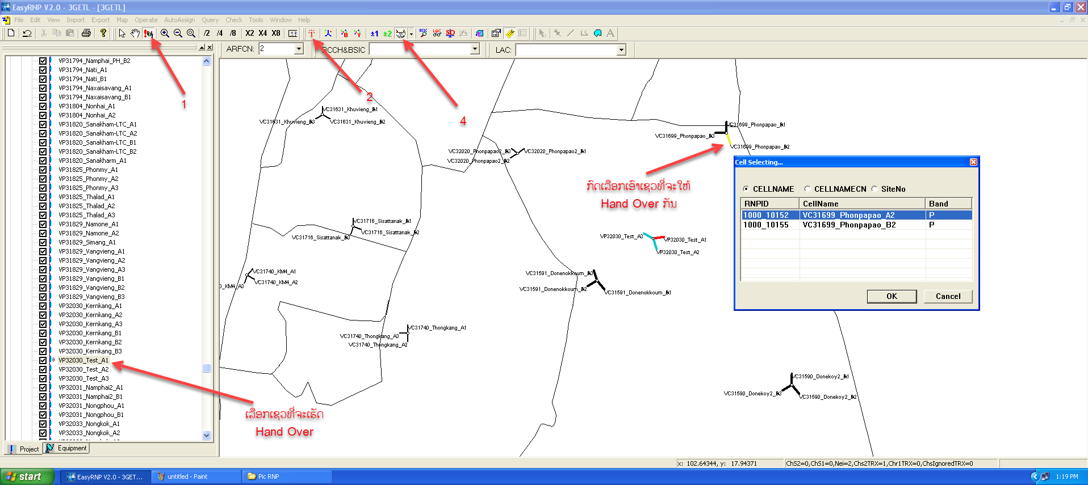
ໝາຍເຫດ: ໃຫ້ສັງເກດຖ້າຂື້ນສີທະເລແມ່ນໄດ້ສ້າງ Hand Over ກັນແລ້ວ , ກົດ1ຄັ້ງແມ່ນສ້າງ Hand Over ກົດ2ຄັ້ງແມ່ນລືມ Hand Over
- Export ຂໍ້ມູມ
