1. **ການ​​ໄປດືງ​ເອົາຂໍ້​ມູນ​​ເພື່ອ​ເຮັດບົດ​ລາຍ​ງານ​ Driving test ​ຂອງ 2G.**

**1. ລະດັບ​ຄວາມ​ແຮງ​ຂອງ​ສັນຍານ 2G.**

* 1. **RxlevSubRoute .**

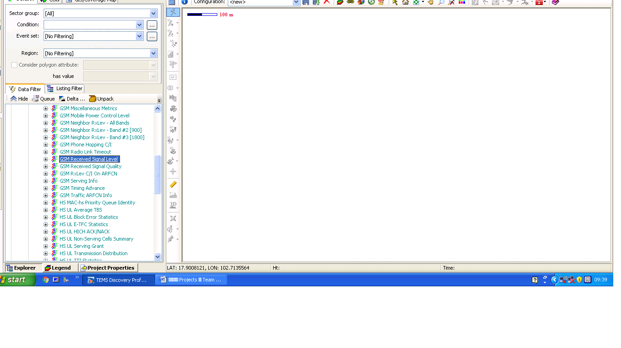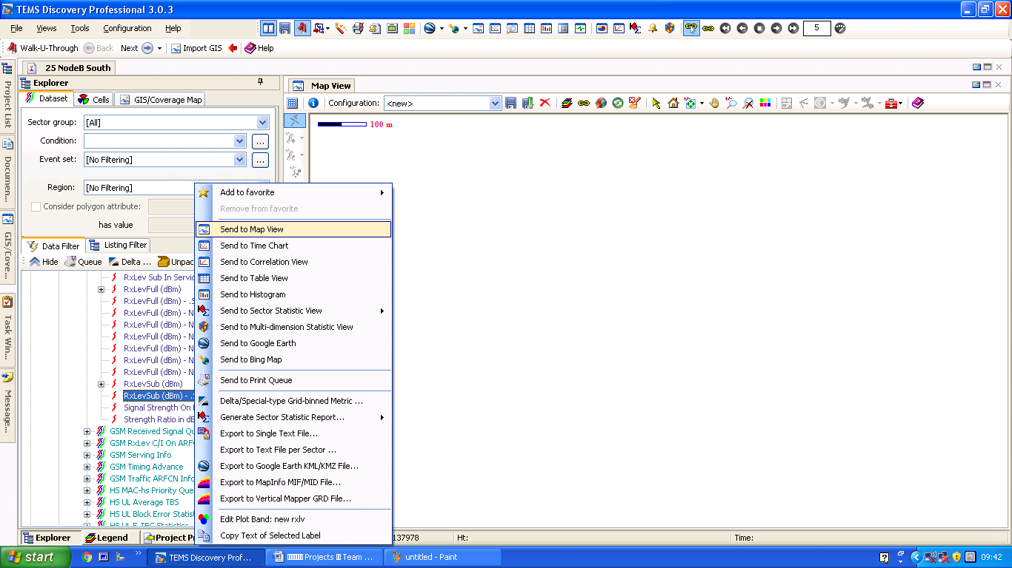​​ແມ່ນໃຫ້ເຂົ້າ​ໄປ​ທີ່ GSM Received Signal Level > RxLevSub (dBm) - .Server > ​ແລ້ວ​ຄຮິ​ກຂວາ Send to Map View.

Send to Map View

RxLevSub (dBm) - .Server

GSM Received Signal Level

* 1. **RxQuality Route.**

ແມ່ນໃຫ້ເຂົ້າ​ໄປ​ທີ່ GSM Received Signal Quality > RxQual Sub > ​ແລ້ວ​ຄຮິ​ກຂວາ Send to Map View.

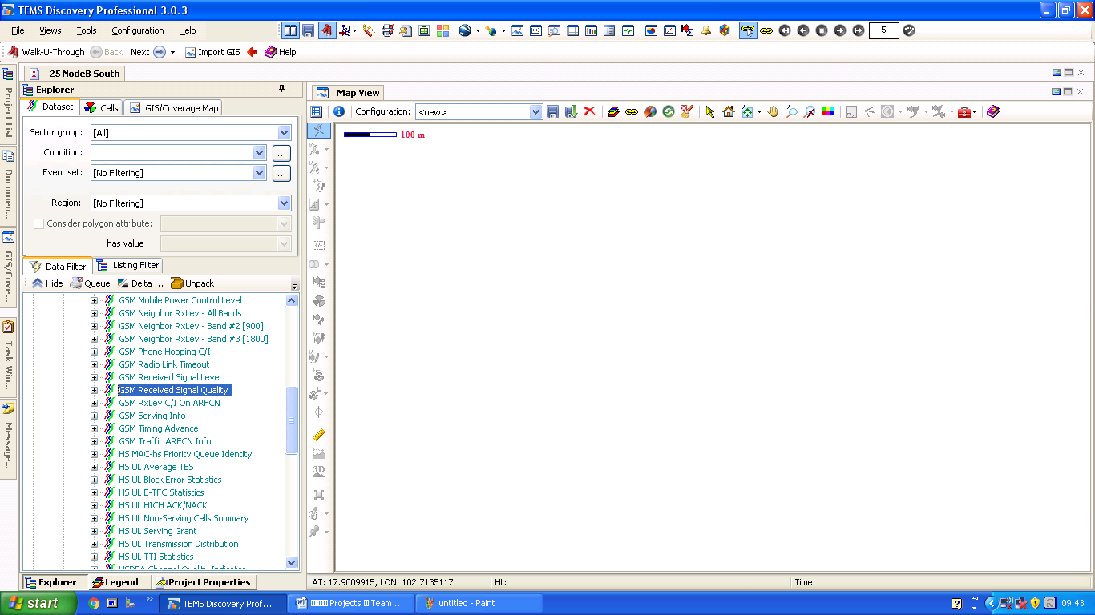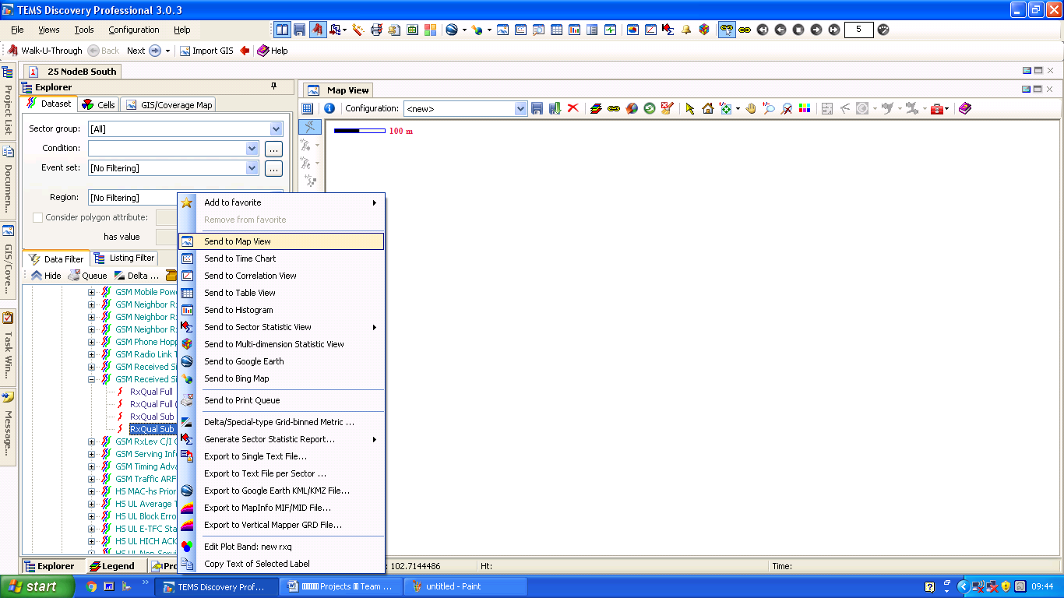

RxQual Sub

Send to Map View

Received Signal Quality

**1.3 RxLevSub Chat.**

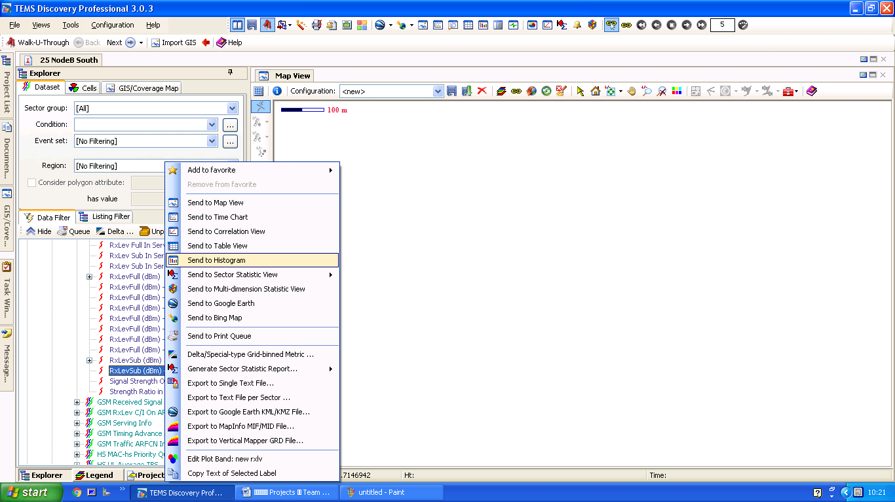ແມ່ນໃຫ້ເຂົ້າ​ໄປ​ທີ່ GSM Received Signal Level > RxLevSub (dBm) - .Server > ​ແລ້ວ​ຄຮິ​ກຂວາ Send to Histogram.

Send to Histogram

GSM Received Signal Level

RxLevSub (dBm) - .Server

**1.4 RxQuality Chat.**

ແມ່ນໃຫ້ເຂົ້າ​ໄປ​ທີ່ GSM Received Signal Quality > RxQual Sub > ​ແລ້ວ​ຄຮິ​ກຂວາ Send to Histogram.

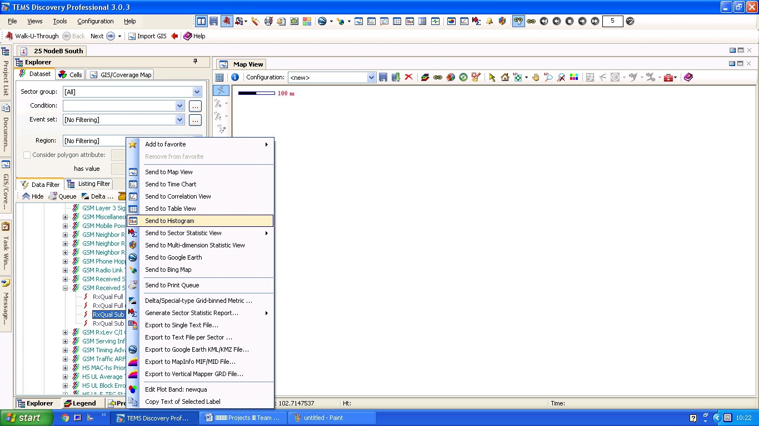

Send to Histogram

GSM Received Signal Quality

RxQual Sub

**2. ສະແດງສະຖານະຂໍ້ມູນໃນການໂທ.**

**2.1 Call Attempt Route.**

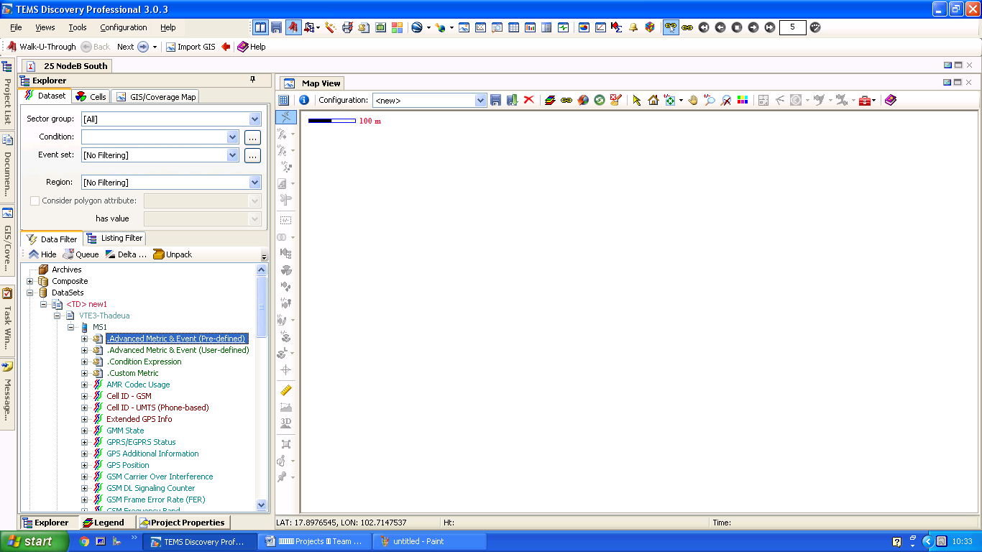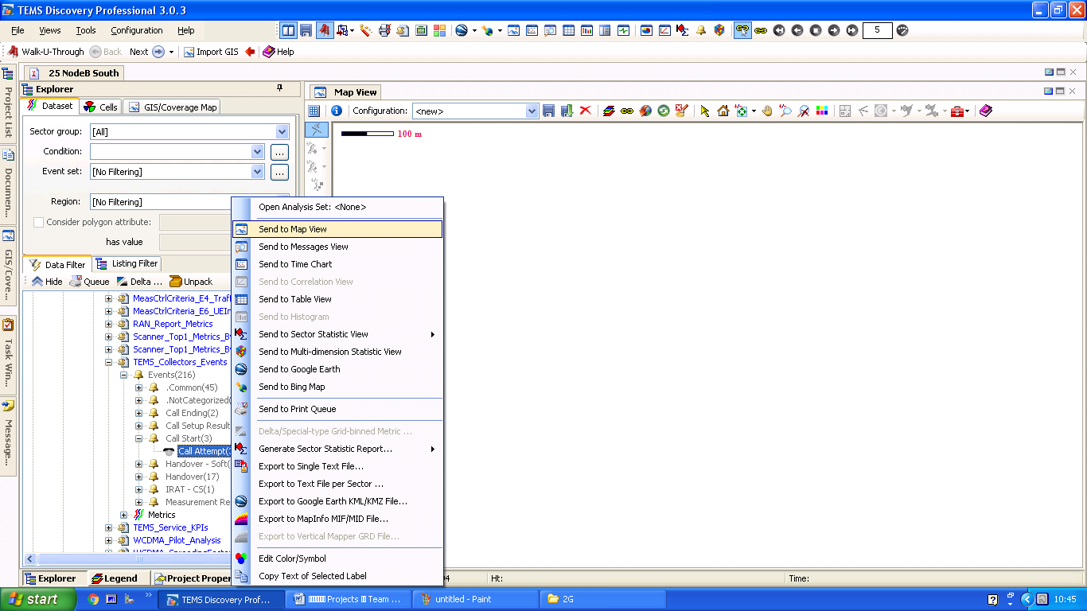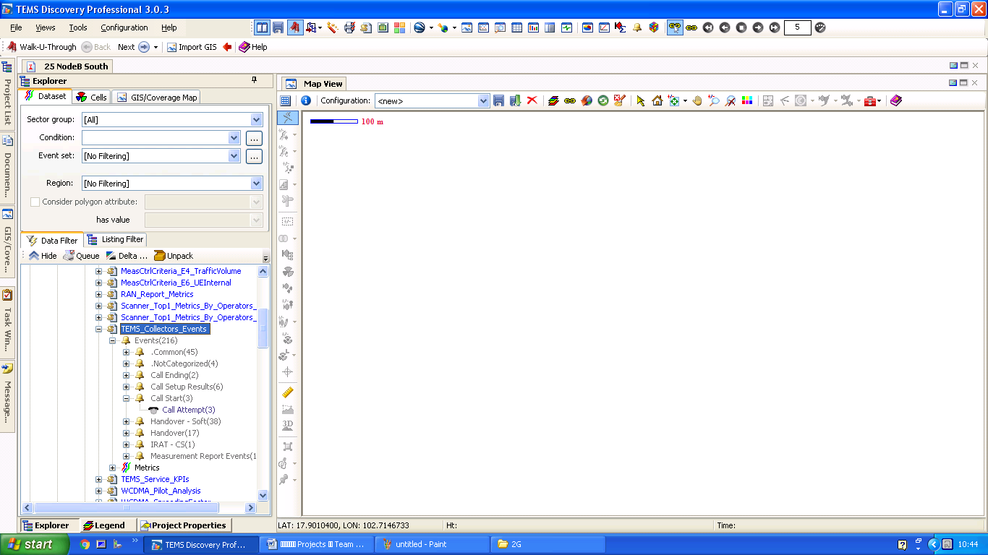ແມ່ນໃຫ້ເຂົ້າ​ໄປ​ທີ່ Advanced Metric & Event (Pre-defined) > TEMS_Collectors_Events > Events > Call Start > Call Attempt > ແລ້ວ​ຄຮິ​ກຂວາ Send to Map View.

Advanced Metric & Event (Pre-defined)

TEMS_Collectors_Events

Send to Map View

Call Start & Call Attempt

**2.2 Call Success Route.**

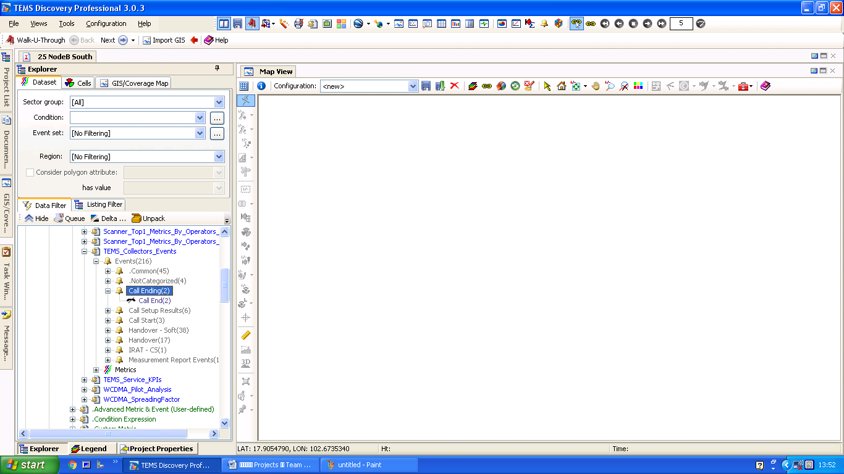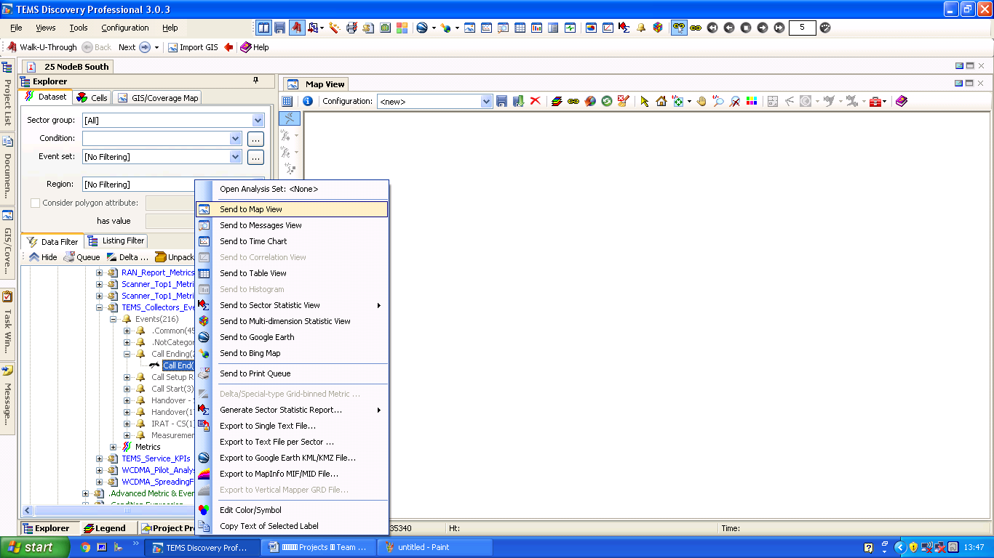ແມ່ນໃຫ້ເຂົ້າ​ໄປ​ທີ່ Advanced Metric & Event (Pre-defined) > TEMS_Collectors_Events > Events > Call Ending > Call End > ແລ້ວ​ຄຮິ​ກຂວາ Send to Map View.

Send to map View

Call Ending

Advanced Metric & Event (Pre-defined)

Call End

**2.3 Call Fail Route.**

ແມ່ນໃຫ້ເຂົ້າ​ໄປ​ທີ່ Advanced Metric & Event (Pre-defined) > TEMS_Collectors_Events > Events > Call Setup Results >

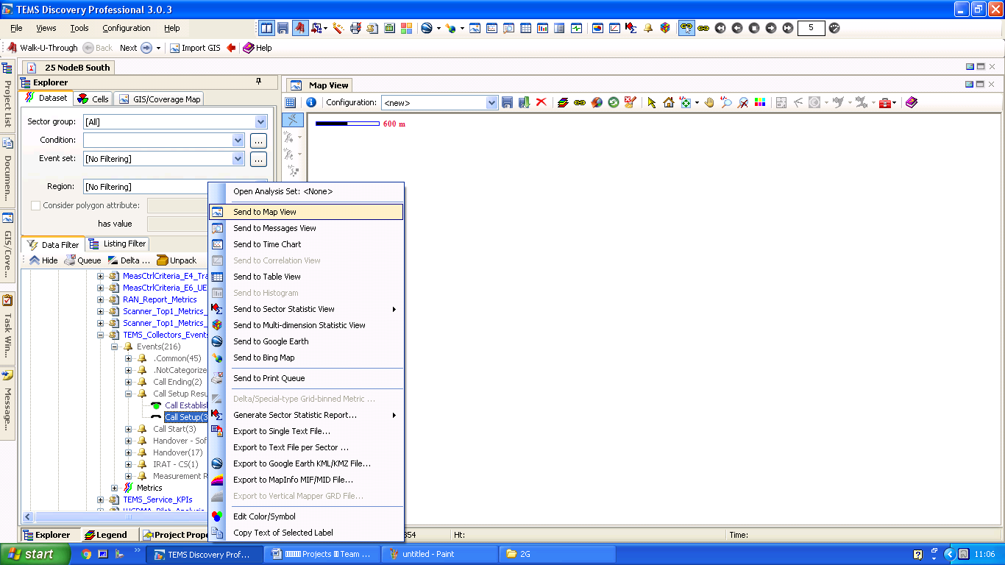Call Fail > ແລ້ວ​ຄຮິ​ກຂວາ Send to Map View (​ໃນ​ກໍລະນີ​ທີ່​​ໂທ​ໄດ້​ປົກ​ກະຕິ​ແມ່ນ​ມັນ​ຈະ​ບໍ່​ໂຊ​ຂື້ນ​ມາ​ໃຫ້​ເຫັນ).

Send to map View

TEMS_Collectors_Events

Advanced Metric & Event (Pre-defined)

Call Fail

**2.4 Call Attempt Table Percent.**

ແມ່ນໃຫ້ເຂົ້າ​ໄປ​ທີ່ Advanced Metric & Event (Pre-defined) > TEMS_Collectors_Events > Events >​ Call Start > ແລ້ວ​ຄຮິ​ກຂວາ Send to Histogram.

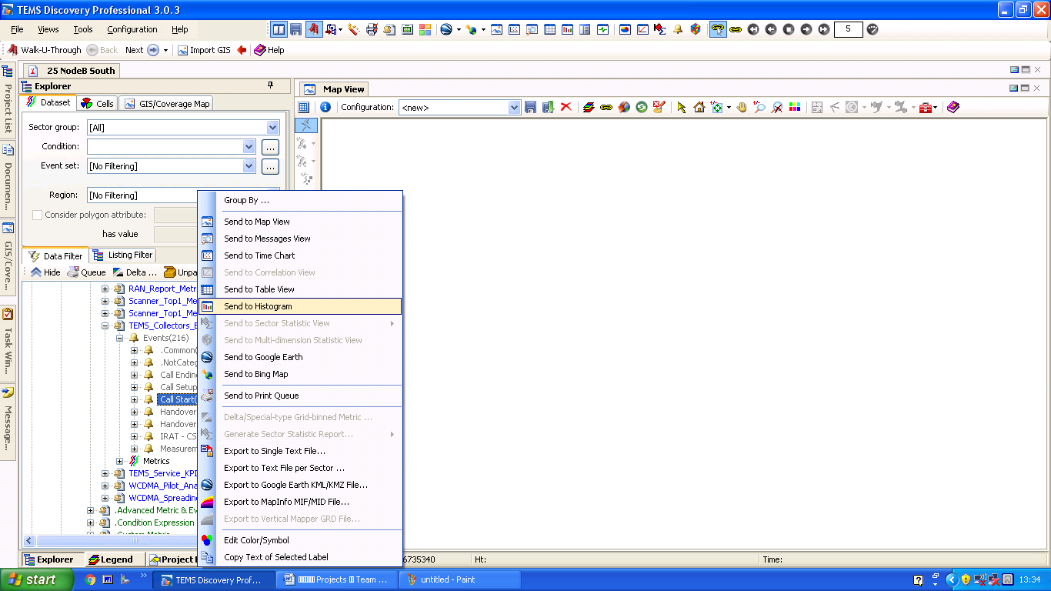

Send to Histogram

TEMS_Collectors_Events

Advanced Metric & Event (Pre-defined)

Call Start

**2.5 Call Success Table.**

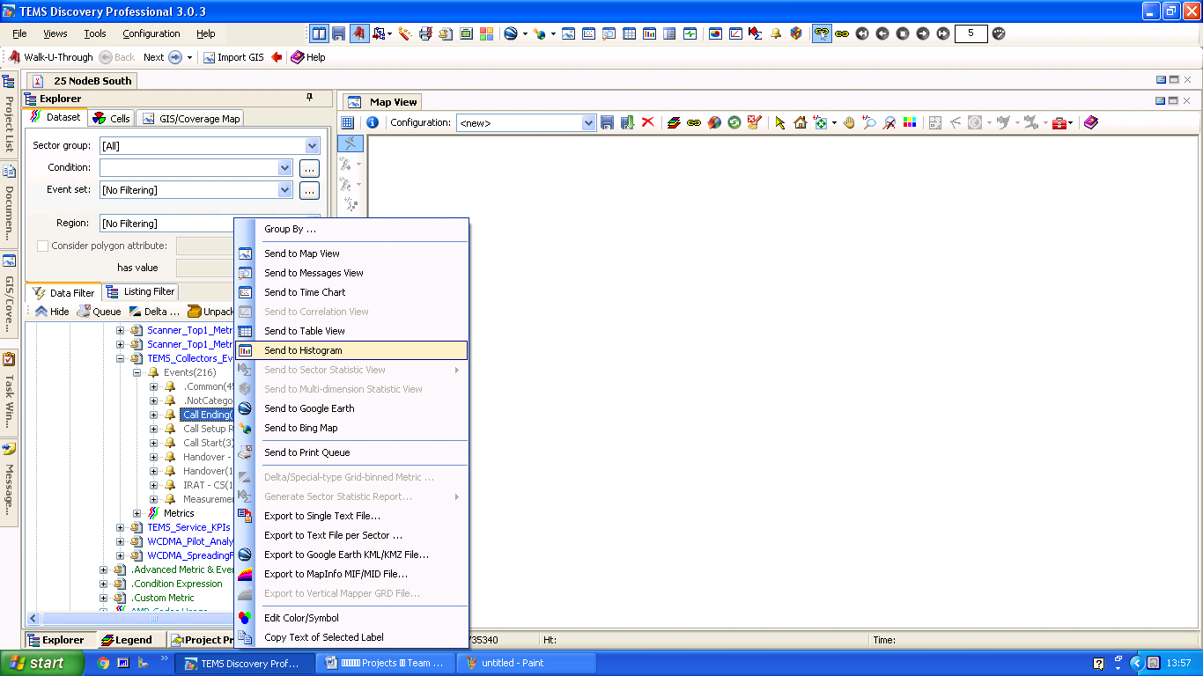ແມ່ນໃຫ້ເຂົ້າ​ໄປ​ທີ່ Advanced Metric & Event (Pre-defined) > TEMS_Collectors_Events > Events > Call Ending > ແລ້ວ​ຄຮິ​ກຂວາ Send to Histogram.

ຄຮິ​ກຂວາ Call Ending

Call Ending

Send to Histogram

Advanced Metric & Event (Pre-defined)

**2.6 HO Success Route.**

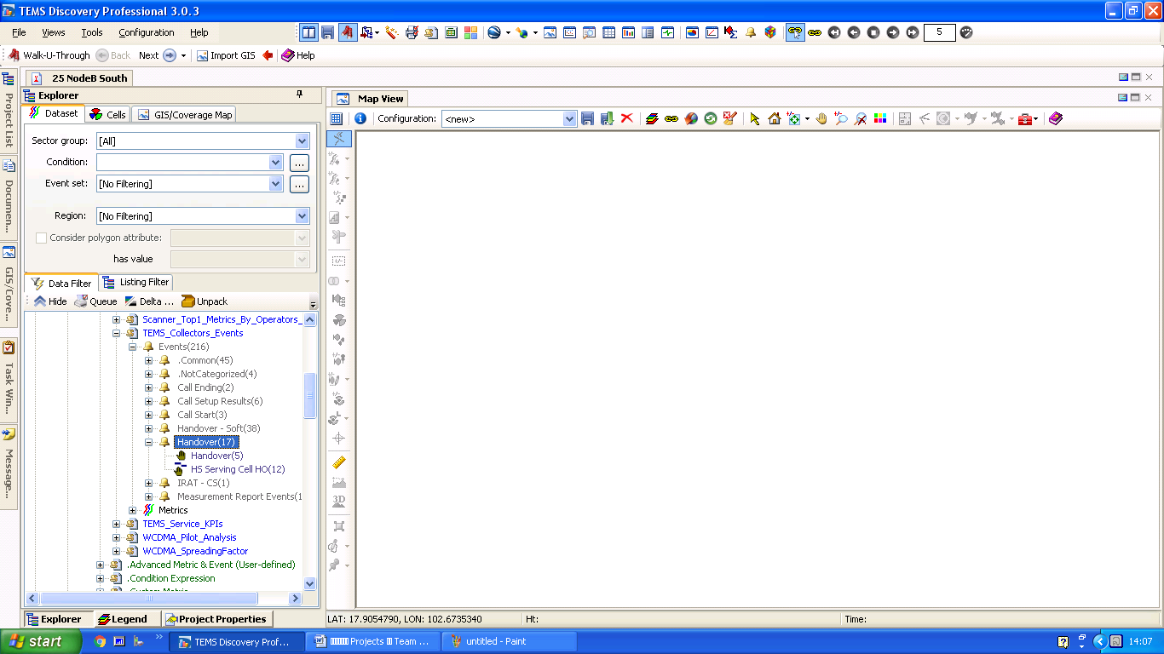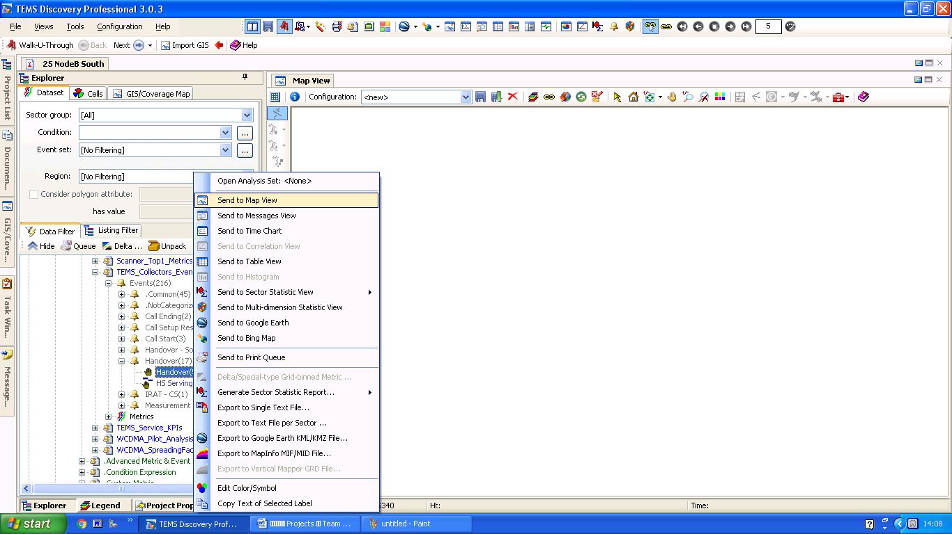ແມ່ນໃຫ້ເຂົ້າ​ໄປ​ທີ່ Advanced Metric & Event (Pre-defined) > TEMS_Collectors_Events > Events > Handover > Handover > ແລ້ວ​ຄຮິ​ກຂວາ Send to Map View.

Send to Map View

Advanced Metric & Event (Pre-defined)

Handover

Handover

**2.7 HO Success Chat Percent.**

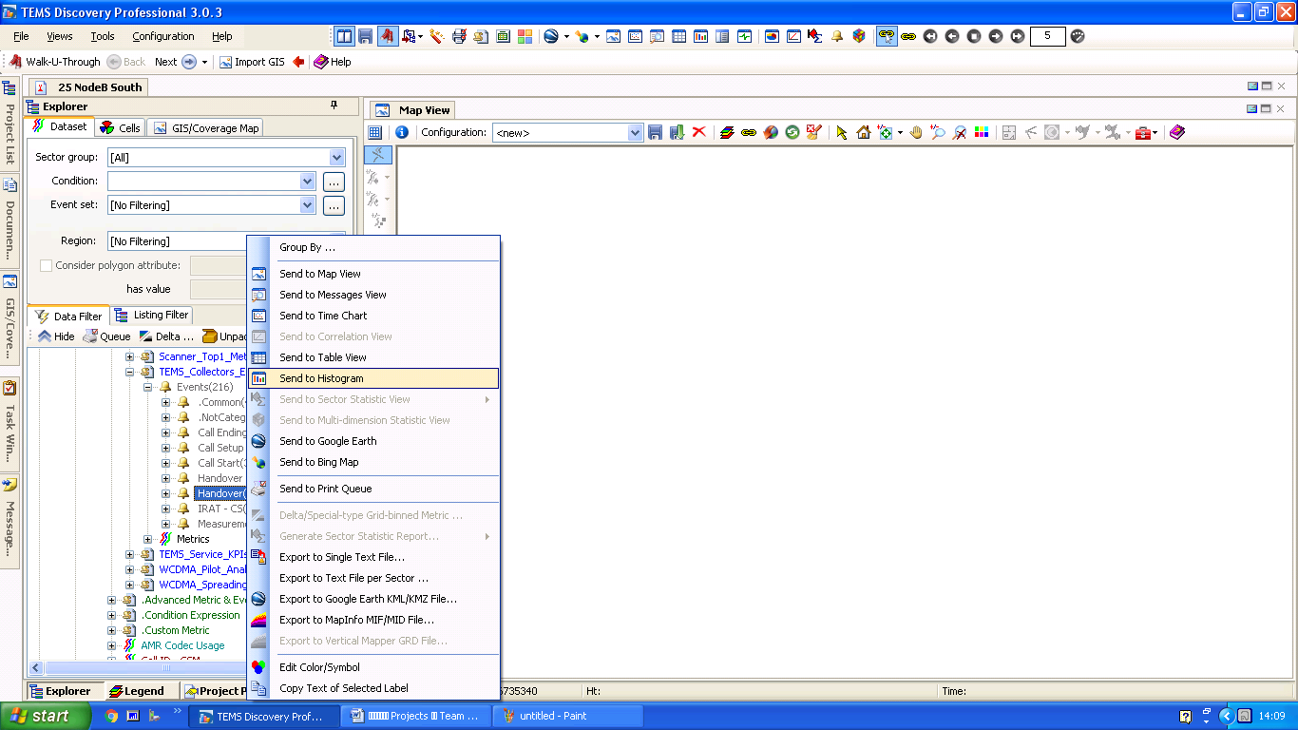ແມ່ນໃຫ້ເຂົ້າ​ໄປ​ທີ່ Advanced Metric & Event (Pre-defined) > TEMS_Collectors_Events > Events > Handover > ແລ້ວ​ຄຮິ​ກຂວາ Send to Histogram.

Send to Histogram

Advanced Metric & Event (Pre-defined)

Handover

Handover

1. **ການ​​ໄປດືງ​ເອົາຂໍ້​ມູນ​​ເພື່ອ​ເຮັດບົດ​ລາຍ​ງານ​ຜົນ Driving test ​ຂອງ 3G.**

**1. ລະດັບ​ຄວາມ​ແຮງ​ຂອງ​ສັນຍານ 3G.**

**1.1 RSCP Route.**

ແມ່ນໃຫ້ເຂົ້າ​ໄປ​ທີ່ WCDMA Rx Tx Power > Rx Power (dBm) > ແລ້ວ​ຄຮິ​ກຂວາ Send to Map View.

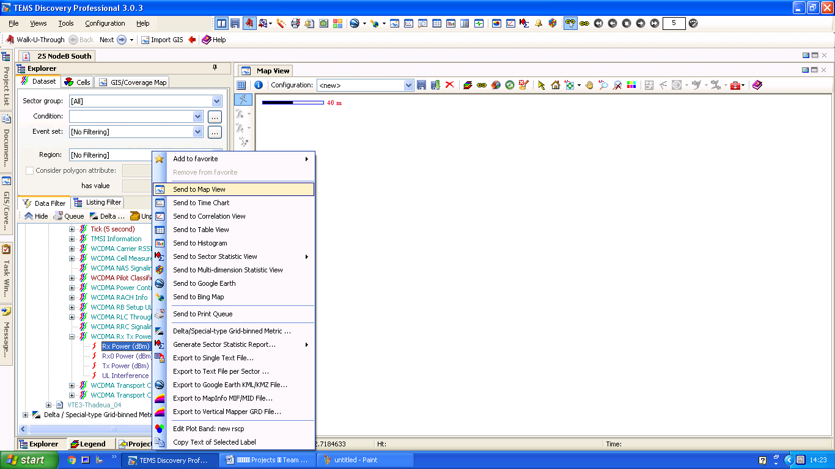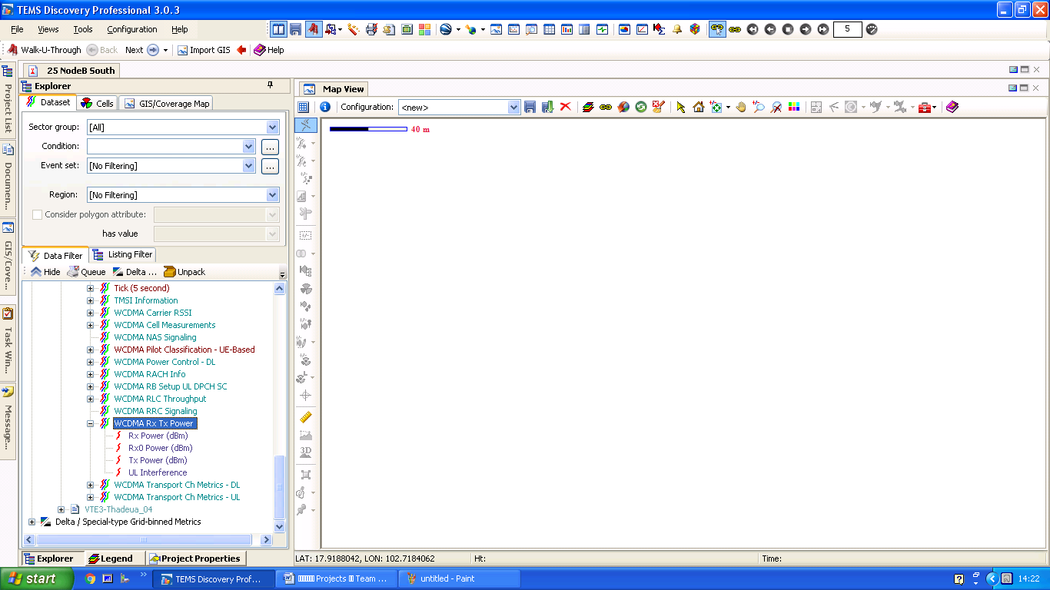

Send to map View

Rx Power (dBm)

WCDMA Rx Tx Power

**1.2 EC-IO Route.**

ແມ່ນໃຫ້ເຂົ້າ​ໄປ​ທີ່ WCDMA Cell Measurements > Agg. Active Ec/Io (dB) > ແລ້ວ​ຄຮິ​ກຂວາ Send to Map View.

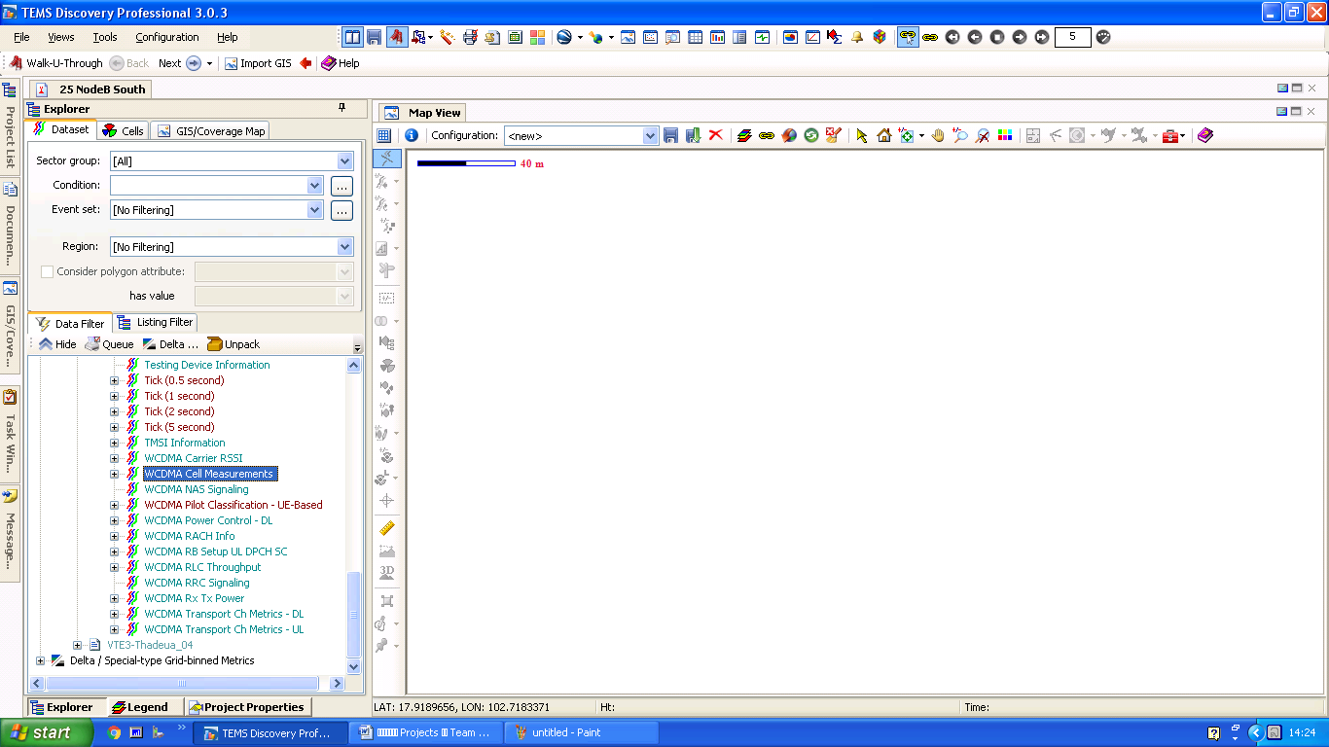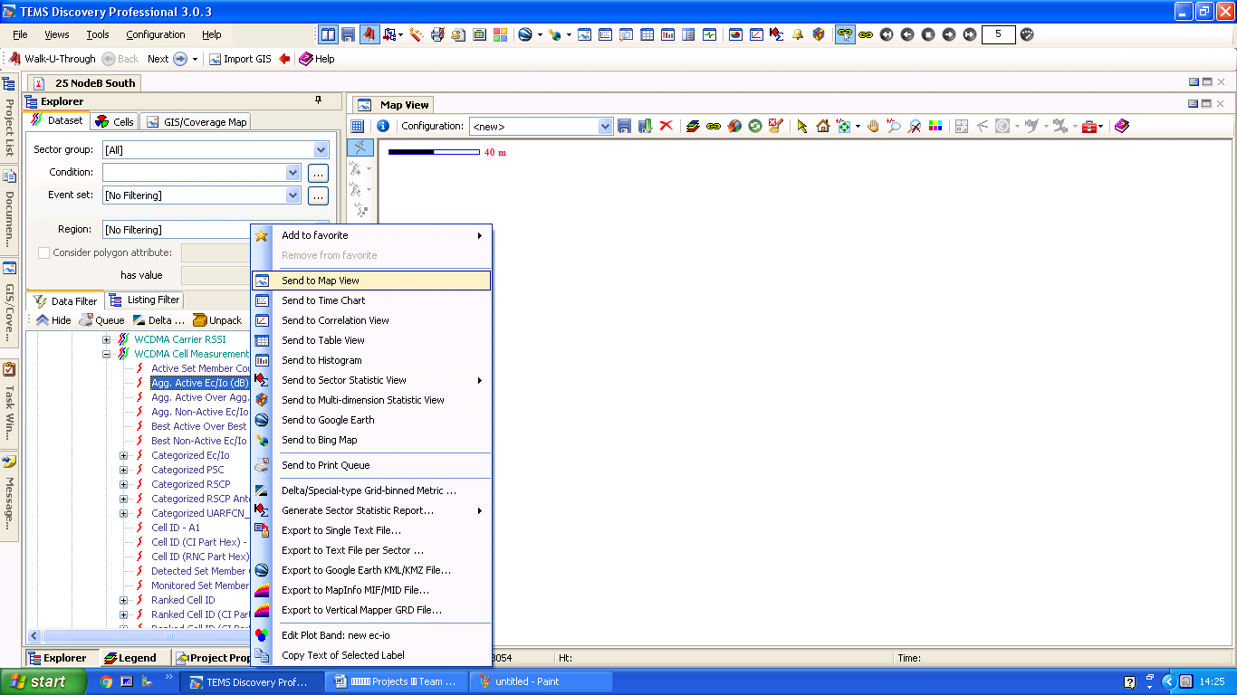

Send to Map View

Agg. Active Ec/Io (dB)

WCDMA Cell Measurements

**2. ລະດັບ​ຄວາມໄວ​ຂອງ​ການຫຼິີ້ນ DATA**

**2.1 HSDAP Station Table test.**

ແມ່ນໃຫ້ເຂົ້າ​ໄປ​ທີ່ WCDMA RLC Throughput > Best RLC DL Throughput (kbps) > ແລ້ວ​ຄຮິ​ກຂວາ Send to Histogram.

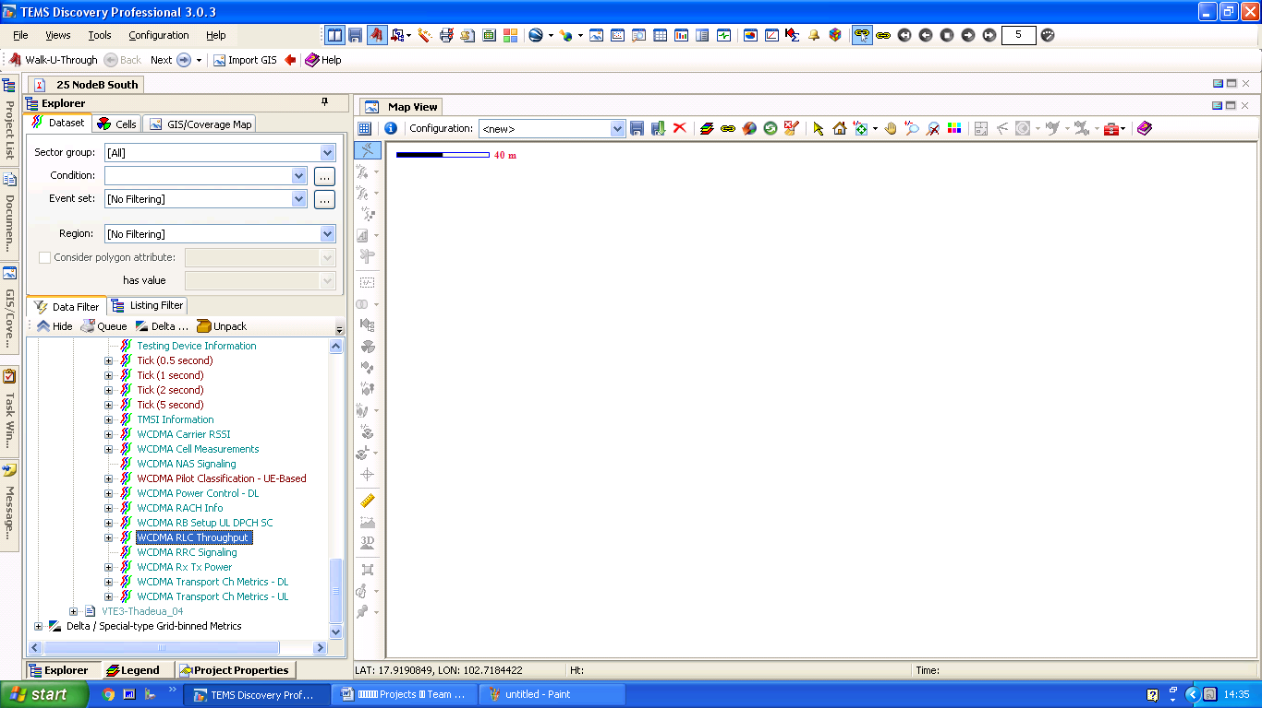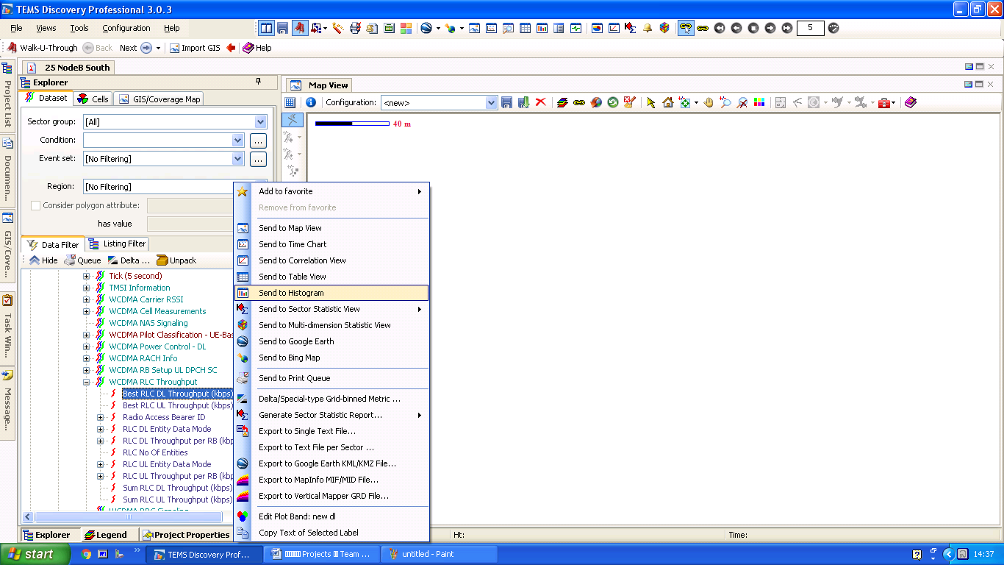

Send to Histogram

Best RLC DL Throughput (kbps)

WCDMA RLC Throughput

**2.2 HSUPA Station Table test.**

ແມ່ນໃຫ້ເຂົ້າ​ໄປ​ທີ່ WCDMA RLC Throughput > Best RLC UL Throughput (kbps) > ແລ້ວ​ຄຮິ​ກຂວາ Send to Histogram.

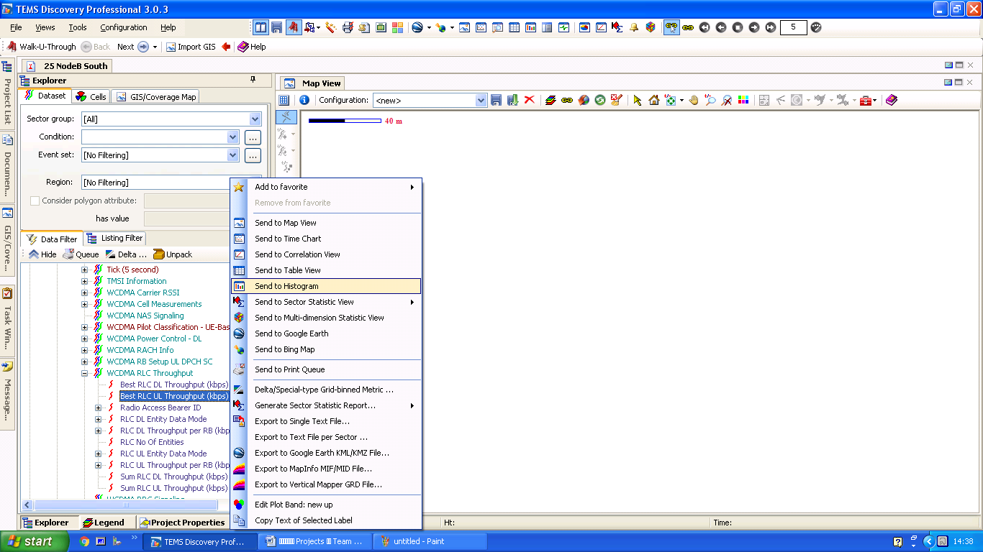

Send to Histogram

Best RLC UL Throughput (kbps)

WCDMA RLC Throughput

**2.3 HSDPA Route.**

ແມ່ນໃຫ້ເຂົ້າ​ໄປ​ທີ່ WCDMA RLC Throughput > Best RLC DL Throughput (kbps) > ແລ້ວ​ຄຮິ​ກຂວາ Send to Map View.

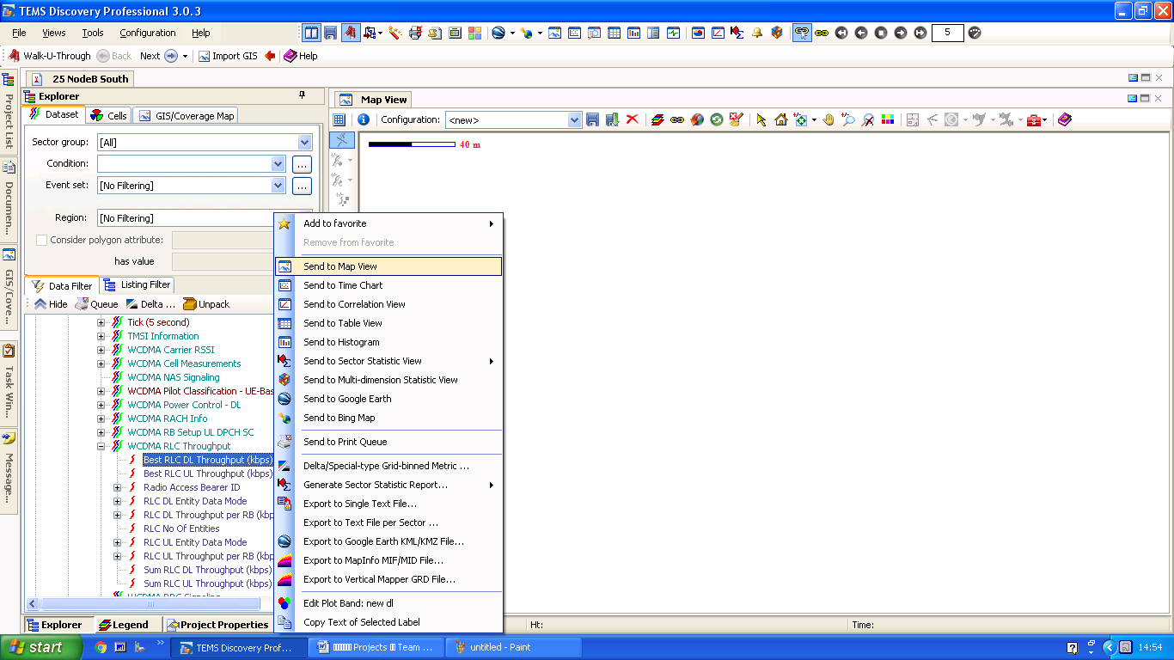

Send to Map View

Best RLC DL Throughput (kbps)

WCDMA RLC Throughput

**2.4 HSUPA Route.**

ແມ່ນ​ໃຫ້ເຂົ້າ​​ໄປ​ທີ່ WCDMA RLC Throughput > Best RLC UL Throughput (kbps) > ແລ້ວ​ຄຮິ​ກຂວາ Send to Map View.

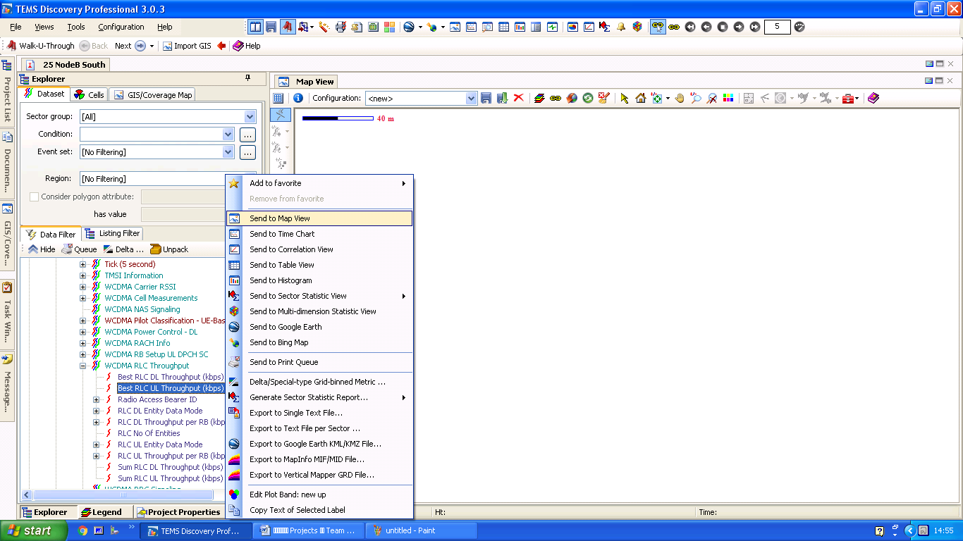

Send to Map View SendSend to Map View.

Map View.

Best RLC UL Throughput (kbps)

WCDMA RLC Throughput

**3. ສະແດງສະຖານະຂໍ້ມູນໃນການໂທ**

**3.1 Call Attempt Route.**

ແມ່ນໃຫ້ເຂົ້າ​ໄປ​ທີ່ Advanced Metric & Event (Pre-defined) > TEMS_Collectors_Events > Events > Call Start > Call Attempt > ແລ້ວ​ຄຮິ​ກຂວາ Send to Map View.

TEMS_Collectors_Events

Advanced Metric & Event (Pre-defined)

Send to Map View SendtSend to Map View.

Map View.

Call Start

**3.2 Call Setup Success Route.**

ແມ່ນໃຫ້ເຂົ້າ​ໄປ​ທີ່ Advanced Metric & Event (Pre-defined) > TEMS_Collectors_Events > Events > Call Ending > Call End > ແລ້ວ​ຄຮິ​ກຂວາ Send to Map View.

Call End

Call Ending

Advanced Metric & Event (Pre-defined)

Send to Map View SendtSend to Map View.

Map View.

**3.3 Call Attempt Chat Percent.**

ແມ່ນໃຫ້ເຂົ້າ​ໄປ​ທີ່ Advanced Metric & Event (Pre-defined) > TEMS_Collectors_Events > Events > Call Start > ແລ້ວ​ຄຮິ​ກຂວາ Send to Histogram.

Send to Histogram

TEMS_Collectors_Events

Advanced Metric & Event (Pre-defined)

Call Start

**3.4 Call Setup Success Chat Percent.**

ແມ່ນໃຫ້ເຂົ້າ​ໄປ​ທີ່ Advanced Metric & Event (Pre-defined) > TEMS_Collectors_Events > Events > Call Ending > ແລ້ວ​ຄຮິ​ກຂວາ Send to Histogram.



Call Ending

Call Ending

Advanced Metric & Event (Pre-defined)

Send to Histogram

**3.5 Handover Route.**

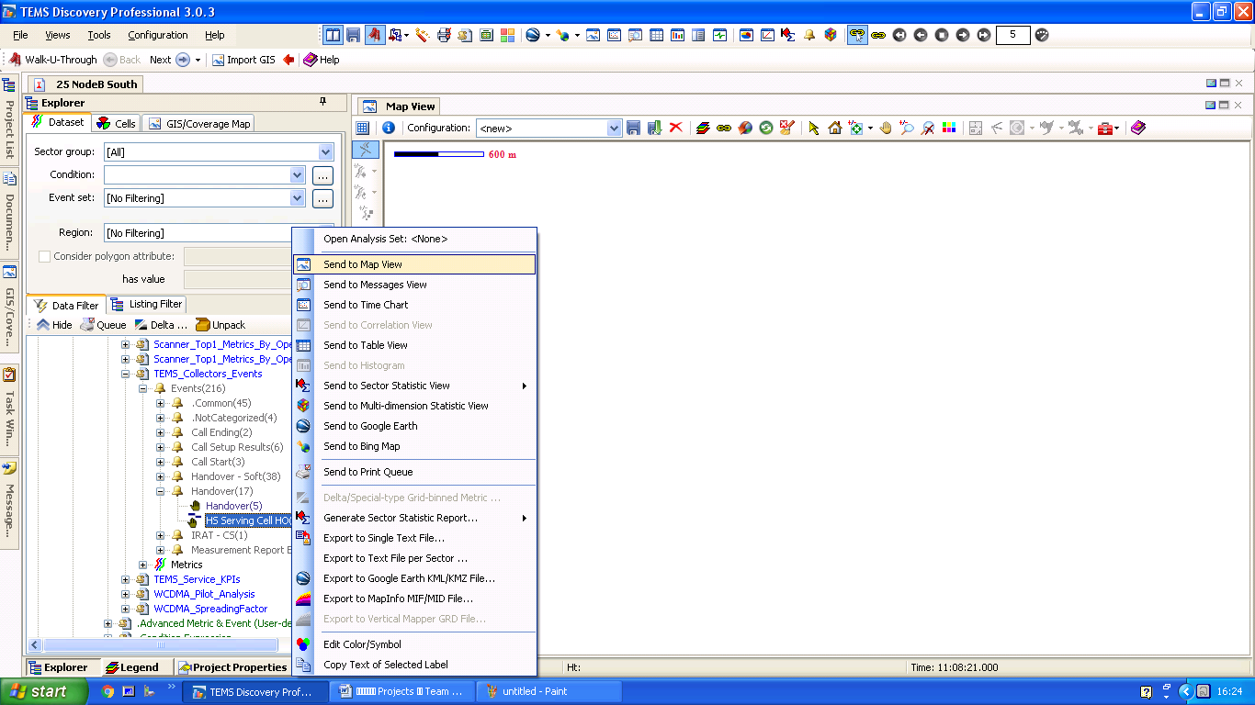ແມ່ນໃຫ້ເຂົ້າ​ໄປ​ທີ່ Advanced Metric & Event (Pre-defined) > TEMS_Collectors_Events > Events > Handover > Handover > ແລ້ວ​ຄຮິ​ກຂວາ Send to Map View.

Send to Map View SendtSend to Map View.

Map View.

Advanced Metric & Event (Pre-defined)

HS Serving Cell HO

Handover

**3.6 Handover Table.**

ແມ່ນໃຫ້ເຂົ້າ​ໄປ​ທີ່ Advanced Metric & Event (Pre-defined) > TEMS_Collectors_Events > Events > Handover > ແລ້ວ​ຄຮິ​ກຂວາ Send to Histogram.

Handover

Handover

Send to Histogram

Advanced Metric & Event (Pre-defined)